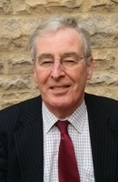
Martin Freeman is Chairman of the UK Radon Association.

He is a member of the Executive Committee of the European Radon Association and is Chairman of the Coalition of International Radon Associations.

With over 40 years’ experience of supplying specialist building services, Martin has been engaged in the remediation of radon for over 25 years and is the Managing Director of PropertECO Ltd.

Among several innovations, Martin has developed a system to solve the difficult problem of combining radon control with waterproofing to British Standard for use in cellar and basement conversions.

Martin is a regular speaker for the professional bodies such as Royal Institute of Chartered Surveyors and Royal Institute of British Architects and has delivered seminars to hundreds of building professionals.

